
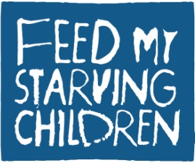
Partnership Opportunities
Food 4others MobilePack 2013

Dear Pastor,

We are excited to announce the return of San Jose’s Food 4others MobilePack, an event that brings together hundreds of volunteers in hand-packing nutritious meals for severely malnourished children across the world. Partnering once again with Feed My Starving Children (FMSC), a Christian, non-profit, hunger relief organization, we will be hosting this event at the San Jose Elks Lodge on May 10-11, 2013.

- Last year, the Food 4others MobilePack was originally scheduled to package 225,000 meals. Due to an increase in funds and volunteers, we produced 241,056 meals!

- This year, for our third annual Food 4others MobilePack, we are planning to package 250,000 meals to feed severely malnourished children around the world!

- This effort will require 1,200 local volunteers packing in 2-hour shifts.

- We are raising a minimum of $55,000 to prepare the meals, which cost $0.22 each.

- Feed My Starving Children distributes these meals to partner organizations working in nearly 70 countries, providing food to children in greatest need.

Consider partnering with us in this city-wide event! You can reach our Community Relations & Events Coordinator, April Hunt at 408-717-1488 or email April@4others.org. We’d love to discuss with you the various options for involvement and levels of commitment.

As a partner, we would assist you by sharing fundraising and promotional resources and helping you mobilize your whole church to get involved.

The Food 4others MobilePack is a great volunteer opportunity for the members of your congregation, providing a tangible way for your church to serve globally. Even children as young as 5 can volunteer with a parent, and there are plenty of opportunities for those who may need to participate from a seated position.

Each two-hour packing session begins with an overview of the hunger crisis and the impact these meals will make in children’s lives. The overview is presented from a Christian perspective and the event provides both a fun and community-building experience. Consequently, many churches have used this event as a community outreach tool to invite friends and co-workers to help pack.

Most importantly, the MobilePack is a simple and effective way to fight child hunger. Today, 1 child dies every 5 seconds from hunger-related causes. Those who survive early childhood malnutrition suffer irreversible harm—including poor physical growth, compromised immune function, and impaired cognitive ability.
The formula for these meals was developed by food scientists from Cargill and General Mills specifically for children struggling with severe malnutrition. This food product includes rice, soy, vegetables, a vegetarian-based chicken flavoring, and a vitamin and mineral mix. As you can see from Omar’s story below, the effects are amazing!

In Isaiah 58:10 we read, “If you spend yourselves in behalf of the hungry and satisfy the needs of the oppressed, then your light will rise in the darkness, and your night will become like the noonday.” Through this event, we are following Jesus’ commands in Scripture to feed the hungry, while also showing our city an example of God’s love and provision.

Please visit our website at www.food4others.org for more details and promotional/ fundraising resources. We look forward to hearing from you!

Sincerely,

Email: food@4others.org
Web: www.food4others.org

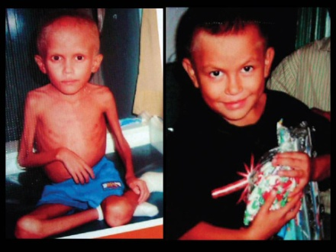
Meet Omar. At age 8, Omar weighed what the average 10 month old American baby weighs. By receiving FMSC meals once a day for six months, Omar regained his health and an appropriate weight. The cost to save his life and bring him to this point was only $44.

Churches involved in 2012’s second annual Food 4others MobilePack included:
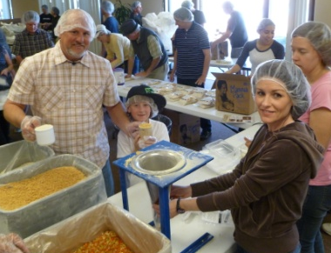
- Orchard Valley Christian Church
- Church of God of San Jose
- Cornerstone Community Church
- Awakening & Westgate Church
- South Bay Agape Christian Church
- Crossroads Bible Church
- Santa Teresa Hills Presbyterian Church
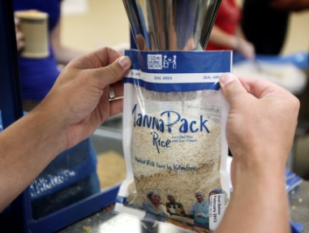
- Missio Dei San Jose
- Logos Baptist Church
- Almaden Neighborhood Church
- Campbell Church of Christ
- …and more!

